

**Updating the malaria risk profile of the Republic of Sudan**

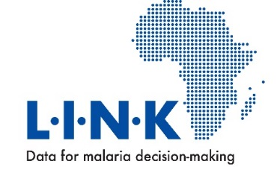**Report prepared for the Federal Ministry of Health, Republic of Sudan by the KEMRI-Wellcome Trust Programme on behalf of the LINK Project, January 2018**

**Contents**

1. Background to previous malaria risk mapping 1

2. Methods 2

2.1 Defining spatial units and margins for malaria risk prediction 2

2.2 Malaria prevalence 4

2.3 Assembling malaria survey data into a single geo-coded repository 4

2.3.1 Data searches 4

2.3.2 Data extraction 5

2.3.3 Geo-coding locations of each survey 5

2.3.4 Parasite prevalence data summaries 6

2.4 Statistical approaches to locality risk mapping 7

2.4.1 Model form 7

2.4.2 Likelihood of policy relevant criteria for intervention 9

2.4.3 Model validation 10

3. Mapping associated special interest areas 10

4. Discussion and recommendations 12

4.1 Overview of findings 12

4.2 Future data needs 12

5. Acknowledgements 14

6. References 14

**1. Background to previous malaria risk mapping**

The earliest attempt to develop a data-driven malaria risk map of the Sudan was undertaken by the Wernsdorfer brothers as part of a WHO supported national pre-eradication survey [Wernsdorfer & Wernsdorfer, 1967]. The survey was undertaken from 1961 to 1963 and included spleen and parasite rates among over 24,000 children aged 2-10 years, detailed descriptions of seasonality, vectors, topography, and assembled health centre morbidity and mortality reports.

During the 1960s the widely held expert opinion was that there were no areas of holo-endemicity in present day Republic of Sudan, but malaria intensity increased to meso-endemic levels further south, malaria was absent in the northern deserts flanking the Nile toward the Red Sea Coast and absent in the areas bordering Egypt, including the Wadi Halfa area [Nasr, 1968]. A similar distribution and intensity was provided in expert opinion maps in the 1980s with a suggestion of a narrow belt of holoendemic malaria along the present day South Sudan border and transmission possible at Wadi Halfa [El Gaddal, 1986].

There has been a long tradition, since the early 1900s, of targeted malaria intervention based on urban sanitation [Balfour et al., 1913] or related to agriculture and irrigation [Sudan Medical Service 1931; Kushkush, 1968]. This approach to geographical targeting lasted throughout the 1970s and 1980s. As interest in malaria control began to wane many spatially defined projects were abandoned and malaria epidemics were witnessed during the late 1990s where previously control had been successful.

A renewed interest in specific project areas was resurrected following the launch of the Roll Back Malaria initiative including the Gezira Malaria Free Initiative [FMoH, 2004], the Khartoum Malaria Free Initiative [FMoH, 2004; Malik et al., 2003], continued support for the project between the Governments of Egypt and Sudan at Wadi Halfa, that started in 1948 to prevent the “invasion” of *An. gambiae* into Egypt [Shousha, 1948], and specific agricultural related projects at Sennar, Roseires Dam and the Rahad irrigation scheme [Malik et al., 2004].

More recent maps used by the Federal Ministry of Health (FMoH) to depict the epidemiological patterns of malaria in Sudan have included those used in the National Malaria Strategic Plan (NMSP) 2007-2012 [NMCP, FMoH, 2006] and the NMSP 2011-2015 [NMCP, FMoH, 2010a] using modelled malaria seasons.

The NMSP 2011-2015, was one of the first within Africa to lay out the foundations of sub-national stratification for control based on ecology, human settlement and malaria transmission. These strata were used develop mixtures of interventions aligned to the diversity of malaria’s epidemiology within the national borders. In addition to the NMSP, these stratifications and maps have also been presented in the Malaria Programme Review (MPR) in 2013 [NMCP, FMoH, 2013a]. The maps were, however, are based on crude approximations of latitudes of risk and the locations of refugees and urban populations, there was no empirical use of epidemiological survey data to define risk classifications and data were not resolved to the decision-making units required by States for sub-national allocation of resources.

As stated by the WHO consultant Dr MA Farid forty years ago “*.. but the fact remains that the basic epidemiology of the dynamics of malaria in the various provinces is still lacking. The malariometric surveys done in scattered areas of the country at one point of time, and the lack of reliable records on malaria morbidity and mortality from various health establishments, reflect the paucity of such basic knowledge*” [Farid, 1974].

In 2011, the KEMRI-Wellcome Trust programme/INFORM project in Nairobi worked with the Federal National Malaria Control Programme (NMCP) to harness available malaria prevalence information and mapped extents of urban settings and refugees to produce a more evidenced based malaria risk map for the country [Noor et al., 2012]. While a useful first attempt following Dr Farid’s plea in the 1970s to use available data, using advances in methods of model based geo-statistics, the final product was not used in programming control, including its absence in the NMSP 2014-2016.

This report, builds on previous collaborative work with the FMoH, to develop a more practical malaria cartography that will better serve the needs of future sub-national control and elimination planning, drawing on additional data generated during the 2016 national Malaria Indicator Survey (MIS) and serve as a locality-specific baseline for future analysis of epidemiological impact.

**2. Methods**

***2.1 Defining spatial units and margins for malaria risk prediction***

Sudan operates a decentralized health system. The Federal Ministry of Health (FMoH) and the 18 States Ministries of Health (SMoH) are jointly mandated to ensure the health of the Sudanese population. The FMoH is responsible for setting of national policies and legislations, intersectoral collaboration, overall supervision and evaluation of the health system, and control of epidemics that pose nationwide threats. In each state, the SMoH is responsible for administration and financing of the health system and support to localities that are responsible for the management of family health centres and family health units. State Level Malaria Control Programmes operationalize control down to the locality where there should, in theory, be a Locality Malaria Control Department and/or Malaria Focal Person [NMCP, FMoH 2013a].

Given the diversity of malaria risk within Sudan’s national borders and the need for State-level malaria decision making, localities represent the most appropriate level of malaria risk stratification. These administrative units have undergone significant revisions over the last five years, most notably in the West and South Kordofan States. A revised nationally approved shapefile of 189 locality boundaries within 18 States was provided for use in November 2016[1]. All locality boundaries that overlapped or not aligned to State boundaries were checked and cleaned [ESRI, 2014].

The vast spaces occupied by the Northern deserts, either side of the Nile, are represented by large locality polygons. Based on historical [Sudan Medical Service, 1931; Nasr, 1968; El Gaddal, 1986; Snow et al., 2017] and contemporary [NMCP, FMoH, 2010a] expert opinion, and mapped extents of aridity [Noor et al., 2012] large swathes of these northern localities, above the 18th Parallel, do not support malaria transmission.

The margins of potential malaria risk have been digitized using combinations of populated settlements [UNOCHA, 2016a], desert fringes [UNEP, 1997] and hyper-aridity [Hijmans et al., 2005; Trabucco et al., 2009] using Google Earth to delineate the risk areas along the Nile from Abu Hamad to the Egyptian border and north of Port Sudan. The final shape file therefore contains 210 locality units, which represent 13 subdivisions of northern localities into risk free and potential risk and three localities into three subdivisions of two free and one risk sub-sectors. The final map is shown in Figure 1, and each locality code is defined in the accompanying excel file.

**Figure 1**: 210 adapted locality divisions across 18 States in Sudan for malaria risk prediction

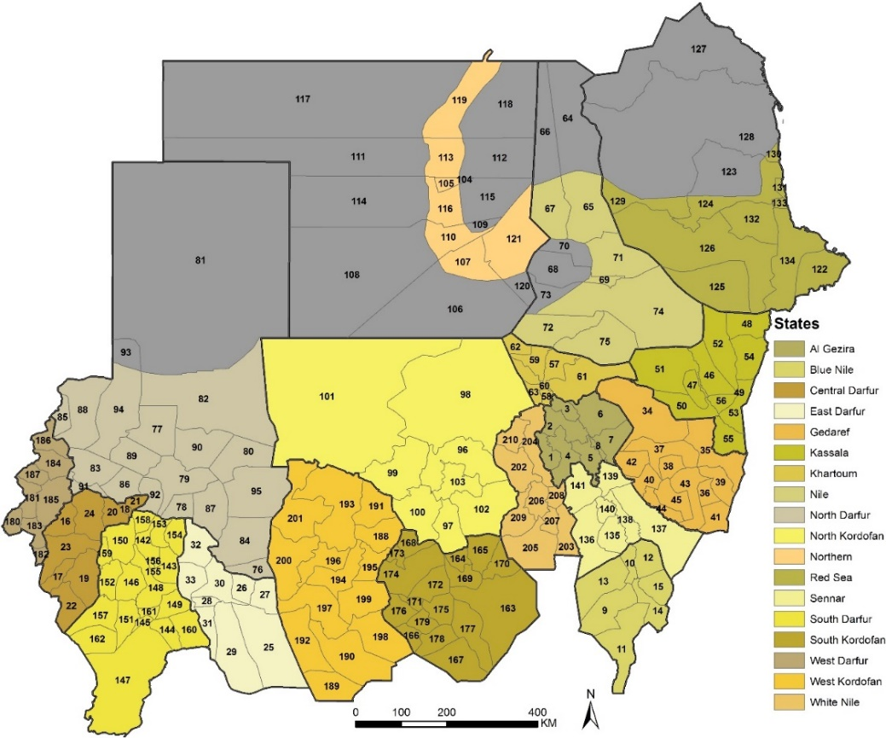

***2.2 Malaria prevalence***

The use of survey data, maps and epidemiological intelligence was a routine feature of control planning across most African countries during the Global Malaria Eradication Programme (GMEP) and exemplified by the work undertaken in the early 1960s in Sudan [Wernsdorfer & Wernsdorfer, 1967]. In the absence of complete and/or reliable routine data on malaria incidence or fever test positivity rates, the prevalence of malaria infection in the community continues to serve as a valuable metric of the quantity of malaria [Snow, 2014; Snow et al., 2017].

Following the conference on malaria in Africa held in Kampala, Uganda in 1950 [WHO, 1950], malaria experts agreed upon a set of classifications of stable malaria endemicity based on the *P. falciparum* infection prevalence in children aged 2-10 years (*Pf*PR2-10) or infants: hypoendemic transmission where *Pf*PR2-10 was less than 10%, mesoendemic transmission where *Pf*PR2-10 was between 10% and 50%, hyperendemic transmission where *Pf*PR2-10 was between 51% and ≤75% and holoendemic transmission where infection prevalence was ≥ 75% [Metselaar & van Thiel, 1959]. Recently these definitions have been reviewed to provide guidelines on when countries, or regions within countries, might elect to develop an elimination agenda [Cohen et al., 2010; GMP, 2017] and there are increasing subdivisions of the hypoendemic classification to include areas defined by a *Pf*PR2-10 of <1%, <5% and 5-<10% [Noor et al., 2014; Giorgi et al., 2018a].

***2.3 Assembling malaria survey data into a single geo-coded repository***

### *2.3.1 Data searches*

Sudan has a rich history of community-based malaria prevalence surveys, ranging from individual research enquiries in small collections of villages, to annual, repeat surveys of locations in special agricultural, urban or elimination areas and national sample survey household surveys. The identification, and curation, of this rich source of information has taken many years. It began in 1996, with the establishment of the Mapping Malaria Risk in Africa/Atlas du Risqué de la Malaria en Afrique (MARA/ARMA) [Snow et al, 1996; Le Sueur et al., 1997], continued from 2005, through the Malaria Atlas Project (MAP) [Hay & Snow, 2006] and was re-established through a specific collaboration between the KEMRI-Wellcome Trust Programme in Nairobi and the FMoH, Sudan from 2009.

Methods to identify sources of information have been opportunistic, cascaded approaches and included the use of personal contacts among the research communities in Sudan, searches of FMoH archives in Giezera, Sennar, Khartoum and Kassala, and a special search of post-graduate theses held at the University of Khartoum and the Institute of Endemic Diseases in 2012. More traditional peer-reviewed publication searches were also performed, including: PubMed, Google Scholar, the World Health Organization Library Database and African Journals Online. In all digital electronic database searches for published work the free text keywords "*malaria*" and "*Sudan*" were used. The last electronic search was completed in June 2017. Finally, survey data from the partial national household survey in 2005 [NMCP, FMoH, 2005] and 2009 [NMCP, FMoH, 2010b], the complete national sample surveys in 2012 [NMCP, FMoH, 2013b] and 2016 [DCNCD, 2017], and annual survey data from Geizera irrigation schemes [Mirghani et al. 2010], Khartoum [Nourein et al. 2011] and the Gambiae project around Wadi Halfa [NMCP personal communication] were provided by the FMoH for analysis. All those who aided in locating historical archive survey reports, university theses and unpublished data or provided help in geo-coding survey data are listed in Section 5.

### *2.3.2 Data extraction*

From each of the survey reports the minimum required data fields for each record were: description of the study area (name, administrative divisions and geographical coordinates, if available), start and end of survey dates (month and year) and information about blood examination (number of individuals tested, number positive for *Plasmodium* infections by species), the methods used to detect infection (microscopy, Rapid Diagnostic Tests (RDTs)) and the lowest and highest age in the surveyed population (decimal years). For data derived from randomized controlled intervention trials, data were only selected when described for baseline, pre-intervention and subsequent follow-up cross-sectional surveys among control populations. Occasionally, reports presented the total numbers of people examined across several villages and only the percentage positive per village; the denominator per village was assumed to be equivalent to the total examined divided by the total number of villages. The month of survey was occasionally not possible to define from the survey report. Descriptions of "wet" and "dry" season, first or second school term or other information was used to make an approximation of the month of survey.

Where age was not specified in the report but a statement was made that the entire village or primary school children examined the age ranges to be 0-99 years or 5-14 years were assumed respectively. Surveys covered many different age ranges, to make meaningful comparisons in time and space, a single standardized age range is required. Correction to a standard age for *P. falciparum* was done using adapted catalytic conversion Muench models, into static equations in R-script that uses the lower and upper range of the sample and the overall prevalence to transform into a predicted estimate in children aged 2-10 years, *Pf*PR2-10 [Smith et al.*,* 2007]

### *2.3.3 Geo-coding locations of each survey*

During data extraction, each data point was recorded with as much geographic information from the source as possible and this was used during the geo-positioning, for example checking the geo-coding placed the survey location in the administrative units described in the report or corresponded to other details in the report on distance to rivers or towns when displayed on Google Earth. According to their spatial representation, data were classified as individual villages, communities or schools or a collection of communities within an area covering a 5-km grid or approximately 0.05 decimal degrees at the equator (point). Preference was given to point data, however, areas more than 5 km2 were classified as “wide-areas” (<10 km2), and those where data was only available across larger administrative units included as “polygons”, and excluded from the analysis.

More recent use of Global Positioning Systems (GPS) during survey work enabled a re-aggregation of household survey data, to increase the sampling precision by combining clusters of small sample sizes in space, while maintaining the 5 km grid criteria. While in theory GPS coordinates should represent an unambiguous spatial location, these required careful re-checking to ensure that the survey location matched the GPS coordinates and all coordinates located on populated communities. To position each survey location where GPS coordinates were not available, a variety of digital resources were used: Microsoft Encarta Encyclopedia, Google Earth, Fallingrain, African Data Sampler, topographical maps of the Wadi Halfa and Giezera areas and digital place names developed by OCHA [UNOCHA, 2016a]. Where only community name and locality were available as location descriptives, and where localities were small polygons, combinations of existing place name geo-coded locations and Google Earth to ensure that a “best-guess” location was established, by positioning the survey on a populated area that was not shown in UNOCHA or other digital place name gazetteers. These are less precise locations, but fall within the margins of populated places in localities where they were surveyed.

### *2.3.4 Parasite prevalence data summaries*

A total of 3515 independent survey data points, 2000-2016, were identified at 1625 unique locations. There were two polygons in Khartoum central and neighbouring Bhary, these were excluded, and 21 locations could not be geo-coded, five during the MIS 2012 and 16 during the MIS 2016. The remaining database included 3492 surveys at 1602 locations. Of these surveys 2445 (70%) used microscopy for parasite detection and 1047 (30%) RDTs (mostly in the national household surveys; First Response, Carestart Pf+Pan combo or SD Bioline Pf/Pv). 2586 (74%) were geo-coded using GPS, 158 (4.5%) using Google Earth, 14 (0.4%) using Encarta, 2 using Geonames, and 705 (20.2%) using UN OCHA place names or other national digital place name gazetteers; 27 (0.8%) were positioned using a best guess within populated places of small localities

This complete, geo-coded database of historical and contemporary survey data (1924-2016), bibliography and digital survey report library is provided to the FMOH with this report.

The data encompass the large survey effort of repeated sampling in Wadi Halfa, Geizera and Khartoum special interest areas between 2000 and 2010 (Figures 2A & 2B). There has been almost no continued surveillance of community-based infection prevalence in Khartoum and Geizera and since 2008 and 2009 respectively. Recent data from Wadi Halfa (post-2010) has not been made available for analysis, however the FMoH confirm that at routine surveillance sites between Labab Island and Al Shabab since 2010 there has been no detected infections (FMoH unpublished data).

**Figure 2**: The age-corrected *P. falciparum* infection rates at 1610 locations 2000-2016 showing the highest values on-top among 3494 surveys 2000-2016 (2A) and lowest values on top (2B)



Between 2000 and 2010, 997 community based surveys used microscopy to detect infection presence and described the presence of *P. vivax*. Among 178,057 people examined only six were shown to harbour vivax infections (0.003%) at five locations including three in Khartoum, compared to 0.54% infections due to *P. falciparum*.

During the MIS in 2016, SD BIOLINE-Malaria Ag P.f/P.v. was used to detect *P. falciparum*, *P. vivax* and mixed infections. Among the 42,102 individuals examined 202 (8.1%) were found to have pure *P. vivax* and 107 (4.3%) had mixed infections with *P. falciparum* at 106 locations, predominantly in the Kordofan and Dafur regions [DCNCD, 2017]. Further analysis of filter paper samples using PCR of species composition is pending.

### *2.4 Statistical approaches to locality risk mapping*

### *2.4.1 Model form*

The analysis of research data undertaken in different parts of the country, regional school surveys and national household survey in one combined way, requires model based geo-statistics (MBG). MBG is a modelling framework that allows us to make the best possible use of the data by providing a statistically principled approach that deals with uncertainty. These statistical methods draw on the basic principle that things that are close in space and time are more related than distant things (also known as the first law of geography), i.e. surveys conducted in the same district will have a more similar measure of malaria risk than surveys in different districts far from each other, or surveys that are one year apart will have a more similar malaria risk than surveys undertaken decades apart [Diggle et al., 2002]. The mathematical details that translate the first law of geography into geo-statistical models are described elsewhere [Giorgi et al., 2018a] and used recently to provide malaria risk maps in Somalia [Giorgi et al., 2018b].

In the current modelling exercise, no environmental or ecological covariates are used to assist in malaria predictions. These become important when data are very sparse, and there is a well-defined biological relationship in each setting with the covariates selected. For the current modelling exercise in Sudan, it is simply assumed that the parasite prevalence at a given location is a product of its climate and control environment, without presuming the biology of climate to infection prevalence.

The spatio-temporal variation in *Pf*PR2-10 was modelled using geostatistical methods [Diggle et al., 2002; Giorgi et al., 2018a; Giorgi et al., 2018b] to borrow strength of information across time and space. Let *x* be the location of a surveyed community in year *t*. We then use *S(x,t)* to denote the variation in malaria risk between communities (e.g. variation due to different environmental conditions) and *Z(x,t)* the variation within communities (i.e. genetic and behavioural traits). In statistical jargon, *S(x,t)* and *Z(x,t)* are so-called random effects that are used in a model in order to capture the effects of unmeasured malaria risk factors.

The input data was the observed *Pf*PR2-10 valuesat location *x* (n=3494) and year *t*. The logit-linear model for *Pf*PR2-10 was defined as

*log{PfPR2-10(x,t)/[1-PfPR2-10(x,t)]} = β + S(x,t) + Z(x,t)*

The *S(x,t)* was modelled as a stationary and isotropic Gaussian process with spatio-temporal correlation function given by

*corr{S(x,t),S(x’,t’)} = exp{-||x-x’||/ϕ}exp{-|t-t’|/ψ}*

where *ϕ* and *ψ* are scale parameters which regulate the rate of decay of the spatial and temporal correlation for increasing distance and time separation, respectively. The notation ||x-x’|| represents the distance in space between the locations of two communities, one at *x* and the other at *x’*. The above equation then indicates that as the distance between *x* and *x’* increases, the spatial correlation will decay at a rate *ϕ*. A similar argument applies to *|t-t’|* which represents the time separation between two surveys.

The model parameters were estimated via maximum likelihood in the R software environment (version 3.4.1) using logit-transformed prevalence [Stanton & Diggle, 2013]. The targets for the predictions were *Pf*PR2-10 over the 1x1 km regular grid surface covering the whole of Sudan. Maps of malaria risk were generated for the years 2005, 2009, 2012 and 2016 in ArcMap version 10.5 (ESRI Inc., Redlands, CA, USA). (Figures x and x)

**Figure X**: continuous predicted *Pf*PR2-10 estimates for Sudan in 2005, 2009, 2012 and 2016, ranging from yellow low to red high through intermediary prevalence blue.

**Figure x**: Predicted quantities of *Pf*PR2-10 in 189 risk localities in 2005, 2009, 2012 and 2016; *Pf*PR2-10 have been binned into 5 risk classes: no transmission (Figure 1: grey), <1%, 1-4%, 5-9% and >= 10%

Overall, there has been a reduction in the numbers of localities that are predicted to have a *Pf*PR2-10 >= 1% since 2005 and a corresponding increase in localities where it is predicted that endemicity is <1% (Figures xx; Figure xx). Areas of highest predicted *Pf*PR2-10 are located along Sudan’s borders with Ethiopia in the East, South Sudan and Central African Republic in the South and South West (Figure 4).

**Figure x**: Proportion of 210 localities in no risk, <1%, 1-4%, 5-9% and 10% prediction categories in 2005, 2009, 2012 and 2016



### *2.4.2. Likelihood of policy relevant criteria for intervention*

One of the objectives of this modelling exercise is to identify areas that are below a prevalence threshold, say *l*. However, the resulting estimates in *Pf*PR2-10 at a location *x* and time *t* (henceforth *Pf*PR2-10*(x,t)*) have uncertainty that needs to be taken into account. It has been shown that classifying areas into different endemic levels purely based on estimates of *Pf*PR2-10*(x,t)* can lead to unwarranted policy decisions [Giorgi et al 2018a]. To overcome this issue, the geostatistical model developed in Section 2.4.1 is used to derive a distribution of the most likely values that *Pf*PR2-10(x,t) can take. We then use this distribution to quantify how likely *Pf*PR2-10*(x,t)* is to be below a threshold l through the so-called non-exceedance probability (NEPs), formally expressed as

*NEP = Probability{ PfPR2-10(x,t) < l | data}*

where *l* is the prevalence threshold which we set here to be less than 1%. In other words, NEP expresses how likely *Pf*PR2-10 is to be below the threshold of 1% *Pf*PR2-10 based on the available survey data. A NEP close to 100% indicates that *Pf*PR2-10, is high likely to be below the threshold of 1%; if close to 0%, *Pf*PR2-10, is high likely to be above the threshold; finally, if close to 50%, *Pf*PR2-10, is equally likely to be above or below the threshold, hence this corresponds to the highest level of uncertainty. This is important when defining the level of certainty of a locality being below 1% and might be considered suitable for elimination, for example one would want to be 80% or 90% certain that this is a real value based on the available data. If a locality does not reach the required level of certainty, additional sampling effort is required in order to classify that into the appropriate endemic level.

Results and figure

### *2.4.3 Model validation*

The models were validated using a cross-validation method, by holding out 10% of the data, corresponding to xxx surveys randomly selected between 2000 to 2016. The predictive performance of the model through the bias, the mean absolute error (MAE) and the correlation between the estimated and observed *Pf*PR2-10 were computed.

Results and figure

### *3. Mapping associated special interest areas*

Urban settings, notably Khartoum, internally displaced populations and large-scale irrigation schemes all feature prominently as unique strata in the NMSP 2011-2015 [NMCP, FMoH, 2010a].

Urban centres of populations more than 50,000 people were identified using the major settlements provided by the online digital gazetteer Geonames [www.geonames.nga.mil/gns/], identifying 33 urban centres (Figure x), including the wider metropolitan area of Khartoum (including Omdurman) which has a combined population of *circa* 5 million people, almost 15% of the total population [CBS & SSCCSE, 2009]. With an urban growth rate ranging between 2.5-3%, it is estimated more that over 15.6 million people will live in urban areas in Sudan by 2020 [CBS, 2010; CBS, 2013; UN, 2014].

Using available information, Sudan hosts just over 0.7 million refugees displaced from neighbouring countries of South Sudan and Eritrea [UNHCR, 2015] and these are housed 34 major refugee settlements [UNOCHA, 2015] (Figure x). Over 3.1 million people were recorded as internally displaced persons (IDPs) in 2016 [UNOCHA, 2015; UNOCHA, 2016b]. The excel includes the reported location of 70 IDP camps in each locality but these are hard to visually present as they are fluid over time

Finally, the major irrigation/agricultural and elimination areas along the Nile, Blue Nile and White Nile and those located in Kassala Province are also shown in Figure x. Irrigation schemes included those listed in the NMSP 2011-2015, Gezira, Elrahad, Kinana, Asalia, West Sinnar, New Halafa & Elzidab, Suki,Khashm (Elgerba).

The spatial extents of urban and refugee settlements and irrigated areas were digitized using online visualization in Google Earth and saved as shapefiles in ArcGIS software version 10.5 (ESRI, Redlands, CA) and are all aligned to localities they are spatially aligned to in the accompanying excel; shapefiles for each of the digitized margins are also provided with this report.

Figure x: Special interest areas for malaria control and elimination

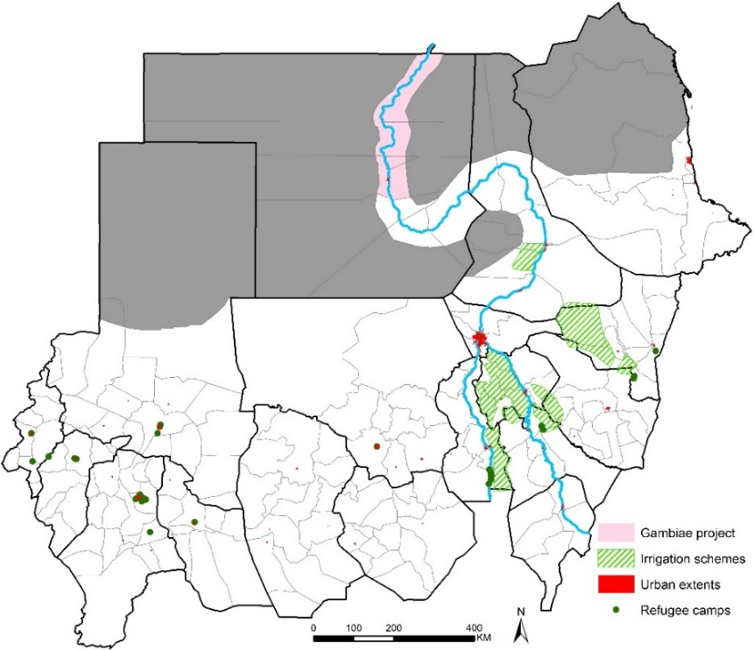

# **4. Discussion and recommendations (draft notes)**

## **4.1 Overview of findings**

This process to model malaria prevalence in this report is different to previous spatial malaria modelling exercises for Sudan, which used a Bayesian point-process model using a variety of environmental covariates (rainfall, urbanization and remotely sensed vegetation indices) to assist in predictions at unsampled locations, trained by data from 2,604 surveys at 913 unique locations sampled between 2000 and 2012 [Noor et al., 2012], where models required three weeks to run using cloud computing facilities.

The model architecture used in this report is simpler, does not require large computing resources, and while the mathematics remains complex, this is being developed into a user-friendly package for the FMoH to use on a desk-top. Furthermore, the assembly of complex layers of covariates has been avoided, so that the prevalence described in communities during survey work is all that is required to make a predictive quantity of risk per decision making unit (locality). The ambition is that when the FMOH assembles new data, for example during a future national indicator survey, models can be re-run by the FMOH without external assistance. Training in this on-line mapping tool will be provided in 2018.

Importantly the revised model allows programmes to select a level of precision they wish to be confident with in the predictive outputs. For Sudan this might include “how certain am I that a locality is *Pf*PR2-10 <1%”. Where this is 80-90% certain, it might be a signal to the programme to revise its approach to control to one of pre-elimination. Or if uncertain (worse case 50%), then this might signal that further, more expanded survey data is required to improve precision [Alegana et al, 2017], which can be done using school-based surveys [Brooker et al., 2009].

It should be noted that prevalence of <1% requires a large statistical sampling effort. Across a large swathe of Sudan, this is a common epidemiological feature and the one policy recommendation, since the days of the GMEP [Yekutiel, 1960; Swaroop et al., 1966], is that the FMoH migrate to using more routine data on fever test positivity rates.

Current epidemiological patterns in Sudan

The country has an exceptionally diverse malaria transmission suitability, governed by latitude, agriculture and thus proximity to the Nile and Blue and White Niles, the huge urban concentration in large cities and the internal conflict that has led to displaced populations.

## **4.2 Future data needs**

## Geizera and Khartoum community-based surveillance suspended in 2008/2009

No published data on prevalence between 2012 and 2016, although there might be in theses.

Effective sample sizes when powered on things other than PR [Alegana et al., 2017]

Species specific analysis

Changing to case-detection in low prevalence/elimination states

The NMCP, FMoH, have historically used urban extents in their stratification of malaria ecologies for targeted control – the specific nature of larval control featured prominently in the Khartoum Malaria Free Initiative, but its less clear what is done in other urban centres. Nevertheless, this stratum is an important one to map reliably and tied to specific intervention in Sudan.

Refugees and displaced populations living in humanitarian camps represent special health needs and organization of services to meet these needs, often provided by UN and NGO aid agencies.

Borders – vivax from Ethiopia

# **5. Acknowledgements**

The authors are grateful to the following individuals who have provided unpublished data, assistance in locating data at archives or geo-coding in Sudan: Mohamed Abbas, Alnazear Abdalla, Mujahid Abdin, Tareg Abdelgader, Nasruddin Abdul-Hadi, Abdalla Ahmed, Mubashar Ahmed, Dalin Abdelkareem Altahir, Sahar Bakhite, Mustafa Dukeen, Tayseer Elamin El Faki, Asma Hsahim El Hassan, Ibrahim El Hassan, Limya El Yamani, Khalid Elmardi, Salah Elbin Elmubark, Homooda Totoa Kafy, Fatih Malik, Jaffar Mirghani, Alaa Moawia, Tasneem Moawia, Abdalla Ahmed Ibrahim Mohammed, Abdullah Sayied Mohammed, Maowia Mukhtar, Fazza Munim, Samia Seif Murghan, Ali Elamin Nasir, Abdisalan Mohamed Noor, Bakari Nour, Abdelhameed Elbirdiri Nugad, A. Omer, Abdala Sayaid, Jihad Eltaher Sulieman, Mohamad Tarig, Randa Youssef

Those who developed the risk modelling work from the KEMRI-Wellcome Trust/INFORM/LINK Project: Michael Chipeta, Emanuele Giorgi, Peter Macharia, Joseph Maina, David Kyalo, Benn Sartorius and Robert W Snow with funds provided by the Wellcome Trust, UK (# 103602) and the Department for International Development, UK (# 203155).

And the continued support of WHO-EMRO, Ghasem Zamani

# **6. References**

Alegana VA, Wright J, Bosco C, Okiro EA, Atkinson PM, Snow RW, Tatem AJ, Noor AM (2017). Prevalence metrics in low- and middle-income countries: An assessment of precision in nationally representative cluster-sample surveys. *Malaria Journal*, **16**: 475

Balfour A (1913). A year’s anti-malarial work at Khartoum. *Journal of Tropical Medicine & Hygiene*, **14**: 227–232

Brooker S, Kolaczinski JH, Gitonga CW, Noor AM, Snow RW (2009). The use of schools for malaria surveillance and programme evaluation in Africa. *Malaria Journal*, **8**: 231

Central Bureau of Statistics (CBS) & Southern Sudan Centre for Census, Statistics & Evaluation (SSCCSE) (2009). *5th Sudan Population and Housing Census 2008*, Priority Results.

Central Bureau of Statistics (CBS) (2010). *Sudan National Baseline Household Survey 2009*. Sudan Central Bureau of Statistics, Khartoum. [www.cbs.gov.sd/en/files.php](http://www.cbs.gov.sd/en/files.php)

Central Bureau of Statistics (CBS) (2013). *Sub-national Population Projections of Sudan and Age-Sex Composition*. [www.cbs.gov.sd/en/files.php](http://www.cbs.gov.sd/en/files.php)

Cohen JM, Moonen B, Snow RW, Smith DL (2010). How absolute is zero? An evaluation of historical and current definitions of malaria elimination. *Malaria Journal*, **9**: 213

Diggle PJ, Tawn JA, Moyeed RA (2002). Model-based geostatistics. *Journal of the Royal Statistical Society: Series C (Applied Statistics)*, **47**: 299–350.

Directorate of Communicable and Non-Communicable Diseases Control (DCNCD) (2017). Sudan Malaria Indicator Survey 2016. Directorate of Communicable and Non-Communicable Diseases Control, Federal Ministry of Health, The Republic of Sudan, Khartoum, June 2017

El Gaddal AA (1986). *Malaria in the Sudan*. In Proceedings of the conference on malaria in Africa: Practical considerations on malaria vaccines and clinical trials. Ed. AA Buck for USAID and AIBS, Washington DC, USA, December 1-4, 1986. Page 157

ESRI Tutorial (2014). Eliminate Sliver Polygons (Data Management). ArcGIS Resource Center. 2014. Accessed June 29, 2015 at [http://tinyurl.com/njseg9h]

Farid MA (1974). Assignment Report: Malaria Control Programme, Sudan, 16 June - 15 July 1974. EM/MAL/126, Sudan 2001/R, August 1974. WHO Archives

Federal Ministry of Health (2004). Documentation of Khartoum and Gezira Malaria Initiatives. Khartoum: Federal Ministry of Health, 1–33

Giorgi E, Diggle P, Snow RW, Noor AM (2018a). Disease mapping and visualization using data from spatiotemporally referenced prevalence surveys. *International Statistical Review*, in press

Giorgi E, Osman AA, Hassan AH, Ali AA, Ibrahim F, Amran JGH, Noor AM, Snow RW (2018b). Using non-exceedance probabilities of policy-relevant prevalence thresholds to identify areas of low malaria transmission in Somalia*. Malaria Journal*, **17**: 88

Global Malaria Programme (2017). A framework for malaria elimination. Geneva: World Health Organization; 2017. License: CC BY-NC-SA3.0 IGO. <http://www.who.int/malaria/publications/atoz/9789241511988/en/>

Hay SI & Snow RW (2006). The Malaria Atlas Project (MAP): developing global maps of malaria risk. *PLoS Medicine*, **3**: e473

Hijmans RJ, Cameron SE, Parra JL, Jones PG, Jarvis A (2005). Very high resolution interpolated climate surfaces for global land areas. *International Journal of Climatology,* **25**: 1965-1978

Kushkush HA (1968). Malaria in The Sudan: malaria, general background, history and its history in The Sudan. University of Khartoum Faculty of Medicine. *Journal of Medical Students Association*, **7**: 105–110

Le Sueur D, Binka F, Lengeler C, De Savigny D, Snow B, Teuscher T, Toure Y (1997). An atlas of malaria in Africa. *Africa Health*, **19**: 23-24

Malik EM, Ahmed ES, Elkhalifa SM, Hussein MA, Suleiman AMN (2003). Stratification of Khartoum urban area by the risk of malaria transmission. *Eastern Mediterranean Health Journal*, **9**: 559–569

Malik EM, Atta HY, Weis M, Land A, Puta C, Lettenmaier C, Bell A (2004). Sudan Roll Back Malaria consultative mission essential actions to support the attainment of the Abuja targets. 16–20 November 2003. Sudan RBM Country Consultative Mission Final Report

Metselaar D & van Thiel PH (1959). Classification of malaria. *Tropical and Geographical Medicine,* **11:** 157–161

Mirghani ES, Nour BYM, Bushra SM, Hassan El I, Snow RW, Noor AM (2010). The spatial-temporal clustering of *Plasmodium falciparum* infection over eleven years in Gezira State, The Sudan. *Malaria Journal*, **9**: 172

Nasr AH (1968). Preparations for future malaria eradication programme in the Republic of the Sudan. *Al Hakeem, University of Khartoum, Faculty of Medicine, Journal of the Medical Students Association*, **7**: 178-190

National Malaria Control Programme (NMCP), Federal Ministry of Health (FMoH) (2005). *Malaria prevalence and coverage indicators survey, Sudan October 2005. Final Report – December 2005*. National Malaria Control Program, Federal Ministry of Health, Khartoum

National Malaria Control Programme (NMCP), Federal Ministry of Health (FMoH) (2006). *National Strategic Plan for RBM: 2007-2012*. Federal Ministry of Health, Republic of Sudan, Khartoum, June 2006.

National Malaria Control Programme (NMCP), Federal Ministry of Health (FMoH) (2010a). *Five years Strategic Plan for The National Malaria Control Programme, Sudan: 2011-2015*. Federal Ministry of Health, Republic of Sudan, Khartoum, 2010.

National Malaria Control Programme (NMCP), Federal Ministry of Health (FMoH) (2010b). *National Malaria Indicator Survey in the northern states of the Sudan 2009*. World Health Organization, Eastern Mediterranean Regional Office, Cairo, Egypt, March 2010

National Malaria Control Programme (NMCP), Federal Ministry of Health (FMoH) (2013a). *Malaria Programme Review 2001-2012*. Federal Ministry of Health, Republic of Sudan, Khartoum, December 2013

National Malaria Control Programme (NMCP), Federal Ministry of Health (FMoH) (2013b). *Malaria Indicator Survey Republic of Sudan – December 2012*. National Malaria Control Programmme, Federal Ministry of Health, Republic of Sudan, Khartoum, September 2013

Noor AM, Elmardi KA, Tarig A, Patil AP, AmineAAA, Bakhite S, Mukhtar M, Snow RW (2012). Malaria risk mapping for control in the Republic of Sudan. *American Journal of Tropical Medicine & Hygiene*, **87**: 1012-1021

Noor AM, Kinyoki DK, Mundia CW, Kabaria CW, Wambua JM, Alegana VA, Fall IS, Snow RW (2014). The changing risk of *Plasmodium falciparum* malaria infection in Africa: 2000–10: a spatial and temporal analysis of transmission intensity. *Lancet*, **383**: 1739-1747

Nourein AB, Abass MA, Abdel Nugud AD, El Hassan I, Snow RW, Noor AM (2011). Identifying residual foci of *Plasmodium falciparum* infections for malaria elimination: the urban context of Khartoum, Sudan. *PLoS One*, **6**: e16948

Shousha AT (1948). The eradication of *A. gambiae* from Upper Egypt, 1942–1945. *Bulletin of World Health Organization*, **1**: 309–348

Smith DL, Guerra CA, Snow RW, Hay SI (2007). Standardizing estimates of malaria prevalence. *Malaria Journal*, **6**: 131

Snow RW (2014). Sixty years trying to define the malaria burden in Africa: have we made any progress? *BMC Medicine*, **12**: 227

Snow RW, Marsh K, le Sueur D (1996). The need for maps of transmission intensity to guide malaria control in Africa. *Parasitology Today*, **12**: 455–457

Snow RW, Sartorius B, Kyalo D, Maina J, Amratia P, Mundia CW, Bejon B, Noor AM (2017). The prevalence of *Plasmodium falciparum* in sub Saharan Africa since 1900. *Nature*, **550**: 515-518

Stanton MC, Diggle PJ (2013). Geostatistical analysis of binomial data: Generalised linear or transformed Gaussian modelling? *Environmetrics*; **24**:158–71

Sudan Medical Service (1931). *Report on medical & health work in The Sudan for the Year 1931*; published Mcorquodake & co. (Sudan) Limited, Khartoum; NPHL-Wellcome Library, Nairobi

Swaroop S, Gilroy AB, Uemura K (1966). Statistical methods in malaria eradication. *Monograph Series of World Health Organization*, **51:** 164

Trabucco A & Zomer RJ (2009). Global potential evapo-transpiration (Global-PET) and global aridity index (Global-Aridity) geo-database. CGIAR Consortium for Spatial Information. Available online from the CGIAR-CSI GeoPortal at: <http://www.csi.cgiar.org>

UNEP (United Nations Environment Programme). *1997. World atlas of desertification 2ED*. UNEP, London

United Nations (2014). *World Urbanization Prospects: The 2014 Revision*, New York: Department of Economic and Social Affairs, Population Division*:* United Nations. http://esa.un.org/unpd/wup/CD-ROM/

UNHCR (2015). *UNHCR historical Refugee Data*. United Nations High Commissioner for Refugees. <http://data.unhcr.org/>

UNOCHA (2015). *Sudan: Humanitarian Snapshot December 2015*. UN Office for the Coordination of Humanitarian Affairs. [www.unocha.org/sudan](http://www.unocha.org/sudan)

UNOCHA (2016a) ‘Sudan Settlements 22 Aug 2011’ dataset with structured p-coded attributes, however positional verification is still as of 2011 [HDX, 2016]. This shapefile was downloaded from OCHA’s Humanitarian Data Exchange portal [http://tinyurl.com/jxrb38f]

UNOCHA (2016b). *Darfur Humanitarian Overview March 2016*. UN Office for the Coordination of Humanitarian Affairs. [www.unocha.org/sudan](http://www.unocha.org/sudan)

Wernsdorfer G & Wernsdorfer W (1967). Malaria in the middle Nile basin and its bordering regions. *Zeitschrift fur Tropenmedizin und Parasitologie*, **18**: 17-44

World Health Organization (1950). *Report on the malaria conference in equatorial Africa*. Held under the joint auspices of the World Health Organization and of the commission for technical co-operation in Africa south of the Sahara. Kampala, Uganda, 27 November–9 December 1950

Yekutiel P (1960). Problems of epidemiology in malaria eradication. *Bulletin of the World Health Organization*, **22**: 669-683

1. Official data provided by Mujahid Abdin, Abd Alla Ibrahim, Khalid Elmerdi and Asma Tohami under letter of agreement for use from Dr Imadeldin AM Ismail, Director General, Planning & International Health, Republic of Sudan