Mapping Malaria Risk in Benin in 2010 and 2012

A Technical Brief

Programme National de Lutte contre le Paludisme, Ministère de la Santé, Porto-Novo, Benin

INFORM, Spatial Health Metrics Group, Department of Public Health Research, KEMRI/University of Oxford-Wellcome Trust Research Programme, Nairobi, Kenya

July 2014

INFORM is an African initiative whose aim is to harness the combined effort of national malaria control programmes, researchers and other regional partners to assemble and package malaria information for efficient national decision making. INFORM is based within the KEMRI-Wellcome Trust Research Programme, Nairobi. The INFORM website is under development on www.inform-malaria.org

Contents
Acknowledgements 3
Abbreviations 4
1.0 Background 5
2.0 General programmatic use of the P. falciparum risk maps and data 5
3.0 Mapping the P. falciparum malaria risk in Benin 6
3.1 Parasite prevalence data assembly 7
3.2 Assembling and testing the ecological and climate predictors of PfPR₂₋₁₀ 9
3.3 Model Based Geostatistical (MBG) mapping of P. falciparum risk in Benin 10
4.0 Provisional interpretation of P. falciparum risk in Benin 16
5.0 References 17

Figure 1 Maps of the extent of the limits of P. falciparum transmission 7

Figure 2 Number of community parasite surveys per year from 9

Figure 3 Maps of the predicted distribution of PfPR2-10 at 1 x 1 km spatial resolution 11

Figure 4 Maps of the standard normal deviate of the predicted mean PfPR2-10. 11

Figure 5 Maps of the distribution of PfPR₂₋₁₀ malaria endemicity at 1 x 1 km 12

Figure 6 Map of the distribution of population at 1 x 1 km spatial resolution 13

Figure 7 Maps of the of population adjusted PfPR2-10 (PAPfPR₂₋₁₀) by district 13

Figure 8 Graph of changing PAPfPR₂₋₁₀ by region in 2010 and 2012 in Benin 14

Figure 9 Pie charts showing the changing population at risk 15

Acknowledgements

The work was undertaken with contributions from the following people:

INFORM, KEMRI-University of Oxford-Wellcome Trust Research Programme: Abdisalan M Noor, Robert W Snow, Eliud Kibuchi, Bernard Mitto, Gilbert Sang, Damaris Kinyoki, Stella Kasura, Jacob Otieno and Clara Mundia.

PNLP, Ministère de la Santé, Benin: Mariam Okê-Sopoh

Roll Back Malaria: Claude Emile Rwagacondo, Ahanahanzo Cesaire Damien, Seck Ndougou, Richard Carrr, Thomas Teuscher

Data and help with geocoding: Cesaire Ahanhanzo; Alexandre Biaou; Vincent Corbel; Umberto D’Alessandro; Georgia B Damien; Marie-Claire Henry; Florence Migot-Nabias; Alain Nahum; Christophe Rogier

Funding: This work was supported by the Roll Back Malaria Partnership with funding from DFID-UK and the Wellcome Trust, UK to Dr Abdisalan Mohamed Noor (# 095127) and to Professor Bob Snow (# 079080)

We acknowledge the support and encouragement provided by the RBM Partnership, the Harmonization Working Group of the RBM and Alistair Robb of the UK government's Department for International Development (DFID).

Main Contacts: Dr Mariam Okê-Sopoh (mariamoke@yahoo.fr) and Dr Abdisalan M Noor (anoor@kemri-wellcome.org)

Abbreviations

DFID-UK Department for International Development – United Kingdom
EVI Enhanced Vegetation Index
GFATM Global Fund to Fight AIDS Tuberculosis & Malaria
INFORM Information for Malaria
INLA Integrated Nested Laplace Approximation
INS Institut National de la Statistique
KEMRI Kenya Medical Research Institute
MBG Model-Based Geostatistics
NFM New Funding Model
NMCP National Malaria Control Programme
NMSP National Malaria Strategic Plan
PAPfPR₂₋₁₀ Population adjusted PfPR2-10
PfPR₂₋₁₀ Plasmodium falciparum parasite rate in children 2 to less than 10 years
PNLP Programme National de Lutte contre le Paludisme
RBM Roll Back Malaria
RDT Rapid Diagnostic Test
SPDE Stochastic Partial Differential Equations
TSI Temperature Suitability Index
WHO World Health Organization

1.0 Background

In 2013 the Global Fund to Fight AIDS Tuberculosis and Malaria (GFATM) launched a new funding model (NFM) which will move applications to the GFATM from a round-based system to a rolling approach. Countries will be awarded an envelope of funding to be shared between malaria, HIV/AIDS and TB [www.theglobalfund.org/en/fundingmodel/]. The NFM requires that countries review their national malaria strategic plans (NMSPs) based on robust epidemiological evidence that will help demonstrate value for money in resource allocation [www.theglobalfund.org/en/fundingmodel/]. The assembled evidence would then form the basis for the development of concept notes to the GFATM for funding requests.

Consequently, national malaria control programmes (NMCPs) from seven countries (Benin, Côte d’Ivoire, Madagascar, Mozambique, Rwanda, Sudan and Yemen) requested the Roll Back Malaria (RBM) Partnership for technical assistance to develop the epidemiological evidence required for the revisions and the NMSPs to be used as part of their NFM concept notes. The RBM contracted the INFORM project to develop maps of Plasmodium falciparum malaria risk for 2000, 2010 and later depending on the availability of data for each country.

2.0 General programmatic use of the P. falciparum risk maps and data

The P. falciparum malaria risk maps developed as part of this project will inform various aspects of country malaria control planning and estimations of resource requirements. The following advice is to guide PNLPs to help them use these maps appropriately:

- These risk maps are measures of transmission intensity using the proportion of people who are likely to be infected with the P. falciparum parasite and not of the clinical incidence of disease.

- In addition to predictions at 1 x 1 km, estimates of parasite prevalence among children 2 to 10 years of age are provided by health district to help with sub-national planning. These can be updated as the number and boundaries of districts change and new parasite rate data become available.

- The estimates of P. falciparum rates per year derived from the maps together with estimates of populations at risk in time are useful to track the changing epidemiology of malaria in Benin and quantify changing malaria intervention needs.

- For making decisions on the targeting vector control and resource gap analysis for insecticide treated nets and indoor residual spraying use the earlier risk maps and not the most recent. This is because in some areas current transmission conditions are likely to be due to the scale up of vector control interventions and withdrawal of these interventions before a long term transition of stability is achieved can result in rebound of malaria.

- Where a country is implementing intermittent preventive treatment of malaria among pregnant women (IPTp) the risk maps can be used to guide targeting. In addition the targeting of seasonal malaria chemoprevention (SMC) requires an understanding of the pre-control levels of malaria risk.

- Areas that where the estimated P. falciparum parasite rate among children aged 2 to 10 years is less than 1% are epidemiologically likely to be at the pre-elimination stage and the use of surveillance data to determine risk and incidence becomes important.

- The 2012 risk map together with information from routine systems can be used to determine where to set up sentinel surveillance sites and to improve the sampling of future malariometric surveys.

3.0 Mapping the P. falciparum malaria risk in Benin

The clinical epidemiology [Snow & Marsh, 2002], the impact of vector control [Killeen et al., 2007; Smith et al., 2009; Griffin et al., 2010], cost-effectiveness of treatment and prevention interventions [Okell et al., 2012] and timelines to malaria elimination [Cohen et al., 2010] are all dependent on pre-control, parasite transmission intensity. There was a recognition over 50 years ago that one important source of planning data was infection prevalence among children aged 2-10 years (PfPR₂₋₁₀), used to define categories of endemic risk designed to guide and monitor progress toward malaria elimination targets [Metselaar & van Thiel, 1959; Macdonald & Göeckel, 1964; Lysenko & Semashko, 1968].

To map malaria risk in Benin, we first defined the changing limits of P. falciparum transmission from 2000-2010 using a combinations of medical intelligence, population distribution, reported case incidence and extreme climatic conditions. Full details of data sources and methods used to define the spatial extents of malaria free, unstable and stable transmission in 2000 and how these margins had changed by 2010 are provided in Snow et al (2012). The maps of districts and the limits of transmission within these districts are shown in Figure 1a and 1b respectively.

Within these limits of P. falciparum transmission, predictions of PfPR₂₋₁₀ were made for the years 2010 and 2012 using carefully selected environmental covariates within a Bayesian geostatistical framework [Noor et al 2014]. To adapt the predicted risk maps for programmatic use, the following endemicity classification were used:

- Malaria Free: Where malaria transmission cannot be supported due to sustained period of low ambient temperature preventing sporozoite development within a time window of a single anopheline population life-span.

- Hypoendemic 1: areas supporting predicted PfPR₂₋₁₀ <5%

- Hypoendemic 2: areas supporting predicted PfPR₂₋₁₀ 5-<10%

- Mesoendemic: areas supporting predicted PfPR₂₋₁₀ 10%-50%

- Hyperendemic: areas supporting predicted PfPR₂₋₁₀ >50%-75%

- Holoendemic: areas supporting predicted PfPR₂₋₁₀ >75%

Figure 1 Maps of Benin: a) showing the health districts; and b) the extent of the limits of P. falciparum transmission in 2010 within these districts. The accompanying spreadsheet have the names of the districts that correspond to the district numbers.
- b)
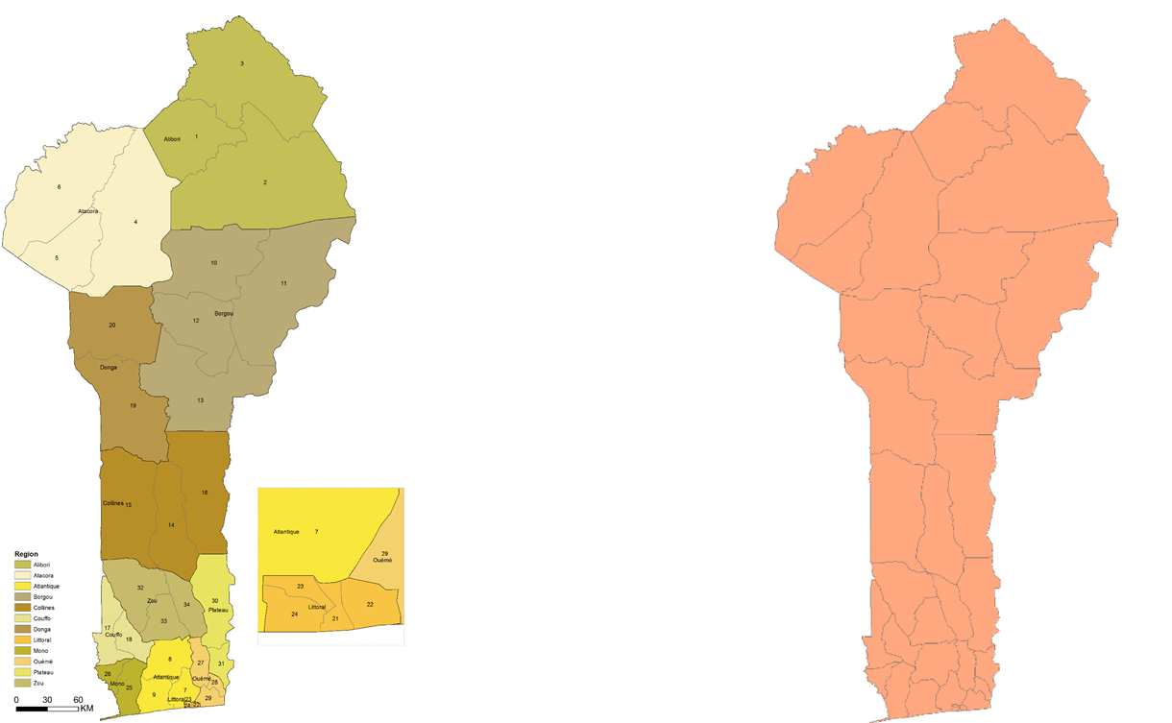

The process of assembly and P. falciparum prevalence data and their use in the prediction of malaria risk in Benin are described in the following sections.

3.1 Parasite prevalence data assembly
A combination of digital (for example PUBMED, MEDLINE, The WHO library and Google Scholar) and physical (visits to national libraries and PNLP archives) searches and unpublished data sources were used to identify possible cross-sectional survey data undertaken in a variety of forms: either as community surveys, school surveys, intervention trials (where pre-intervention, baseline and control groups could be identified). Community-based survey data undertaken as part of national or state level surveys supported by bi-lateral partners through survey agencies or NGO partners were also obtained. These data were provided mainly by the PNLP Benin and partners. Data used in this analysis included those, the malaria indicator surveys of 2012 [INS 2013] and other published and unpublished data.

The minimum required data fields for each record were: description of the study area (name, administrative divisions and geographical coordinates, if available), the dates of start and end of the survey (month and year) and information about blood examination (number of individuals tested, number positive for Plasmodium infections by species), the methods used to detect infection (microscopy, Rapid Diagnostic Tests (RDTs)) and the lowest and highest age in the surveyed population.

To position each survey location in space we used a variety of digital resources, amongst which the most useful were Microsoft Encarta Encyclopedia (Microsoft, 2004) and Google Earth (Google, 2009). Other sources of digital place name archives routinely used included GEOnet Names Server of the National Geospatial-Intelligence Agency, USA (http://www.earth-info.nga.mil/gns/html/cntry_files.html); Falling Rain Genomics’ Global Gazetteer (http://www.fallingrain.com); and Alexandria Digital Library prepared by University of California, USA (http://www.alexandria.ucsb.edu). Data were excluded from analysis if they could not geocoded or the sample size was less than 10 persons examined to maintain adequate precision in our estimates which are compromised under low sample sizes. Although the original MIS data contained 735 clusters, 688 (94%) had sample size of less than 10 people examined. The inclusion of data of such low sample sizes in the model would have compromised the precision of predictions. Instead clusters close in distance (within 5km of each other) were combined into aggregate cluster. Through this process, the MIS 2012 data were reduced to 184 clusters with sample size greater than equal to 10 persons examined. These data together with 90 clusters from the period 1980-2011 were included in the prediction of malaria risk in Benin (Figure 2).

There was a large diversity in the age ranges of sampled populations between studies. To make any meaningful comparisons in time and space a single standardized age range is required. Correction to a standard age for Plasmodium falciparum is possible based on the observation and theory of infectious diseases where immunity is acquired following repeated exposure from birth. The classical age range of 2-10 years was retained as this best describes the exposure to infection among semi-immune hosts at any given location and conforms to classifications established in the 1950s [Metselaar & Van Thiel, 1959]. We have adapted catalytic conversion Muench models, first used in malaria by Pull & Grab (1974), into static equations in R-script that uses the lower and upper range of the sample and the overall prevalence to transform into a predicted estimate in children aged 2-10 years, PfPR₂₋₁₀ [Smith et al., 2007]. The spatial distribution of the PfPR₂₋₁₀ data points are presented in Figure 3 showing that most of the surveys were undertaken in areas within the stable limits of transmission.

Figure 2 Map of the distribution of PfPR₂₋₁₀ locations from 1980-2012 by district against the limit of transmission in 2010

3.2 Assembling and testing the ecological and climate predictors of PfPR₂₋₁₀
Ecological and climatic heterogeneity affect the development and survival of the Plasmodium parasite and the malaria-transmitting Anopheles vectors. Environmental covariates are therefore commonly used to improve the precision of malaria risk modelling and traditionally include measures of aridity, vegetation, rainfall, temperature, proximity to water bodies and urbanization. These are derived from meteorological, topographical and remotely sensed satellite sources or census data. For each survey location we extracted the values of urbanization, precipitation, enhanced vegetation index (EVI) and temperature suitability index (TSI) using ArcGIS 10 (ESRI Inc., USA). Detailed description of these covariates are found in Noor et al (2014). These covariates were used within a total sets analysis with PfPR₂₋₁₀ as the dependent variable. In Benin EVI, TSI and urbanization were selected as the best fitting (Table 1) and were used in the mapping of P. falciparum risk for the 1980-2012 data.

Table 1: Covariates selected as the best fitting predictive model for predicting PfPR₂₋₁₀

Variable | Estimate | Std Error | t-value | P-value | 5% CI | 95% CI
Intercept | 0.91592249 | 0.10816777 | 8.467610 | 0.001 | 0.7029594 | 1.12888558
EVI | -0.6965975 | 0.11097707 | -4.308128 | 0.001 | -0.6965975 | -0.2596093
TSI | -0.9409319 | 0.16213933 | -3.834408 | 0.001 | -0.9109319 | -0.3024849
Urbanization | -0.08238403 | 0.03478874 | -2.368123 | 0.002 | -0.1508769 | -0.0138912

3.3 Model Based Geostatistical (MBG) mapping of P. falciparum risk in Benin
Model Based Geostatistics (MBG) were developed to interpolate from sparse information of known locations in space and time to provide predictions of quantities at locations and times where data do not exist. We have used a Bayesian hierarchical spatial-temporal model was implemented through the Stochastic Partial Differential Equations (SPDE) approach using Integrated Nested Laplace Approximations (INLA) to produce continuous maps of PfPR₂₋₁₀ at 1 × 1 km spatial resolution using data from 1980-2012. Technical details of model specifications are presented in Noor et al. 2014.

Data were used from 1980-2012 with the selected covariates to provide at each 1 x 1 km grid location estimates of the posterior annual mean PfPR₂₋₁₀ for the predictions during the years 2010 and 2012 (Figures 3a-3b). Model accuracy was estimated by computing the linear correlation, the mean prediction error (MPE) and mean absolute prediction error (MAPE) of the observations and predictions of a 10% hold-out dataset. . The linear correlation of the observed and predicted PfPR₂₋₁₀ was 0.70, the MPE and MAPE were -1.5% and 18.9% respectively indicating moderately good model fit. The estimates of the normal standard deviates of the posterior mean PfPR₂₋₁₀ are shown in Figure 4a-4b.

These continuous maps were transformed into endemicity class maps based on the categories described in section 3 (Figures 5a-5b)

Figure 3 Maps of the predicted distribution of PfPR₂₋₁₀ at 1 x 1 km spatial resolution in Benin in: a) 2010; b) 2012
- b)

Figure 4 Maps of the distribution of the standard normal deviate of the predicted mean PfPR₂₋₁₀ malaria endemicity at 1 x 1km spatial resolution in Benin in: a) 2010; and b). The higher the value of the deviate the higher the uncertainty of the posterior mean PfPR₂₋₁₀.
- b)

Figure 5 Maps of the distribution of PfPR₂₋₁₀ malaria endemicity at 1 x 1 km spatial resolution in Benin in: a) 2010; and b) 2012.
- b)

Population distributions at 1 x 1 km spatial resolution for Benin were downloaded from the WorldPop Project website (www.worldpop.org) and highlight the over-dispersed nature of settlement in Benin (Figure 6). From the PfPR₂₋₁₀ endemicity class maps (Figures 5a-5b) the modeled prediction of P. falciparum malaria transmission intensity is equally heterogeneous in 2010 and 2012. We have used a combination of population density and PfPR₂₋₁₀ risk to compute a Population Adjusted PfPR₂₋₁₀ (PAPfPR₂₋₁₀) so that this reflects the underlying diversity of human settlement and malaria risk within a district (see Figures 7a – 7b and accompanying excel file). We then computed the changing PAPfPR₂₋₁₀ by governorate (Figure 8) and the changing population at risk by year nationally (Figure 9).

Figure 6 District map of Benin showing the distribution of population at 1 x 1 km spatial resolution in 2010
Figure 7 District maps of the of population adjusted PfPR₂₋₁₀ (PAPfPR₂₋₁₀) in Benin in: a) 2010; and b) 2010.
- b)
Figure 8 Graph of changing PAPfPR₂₋₁₀ by region in 2010 and 2012 in Benin
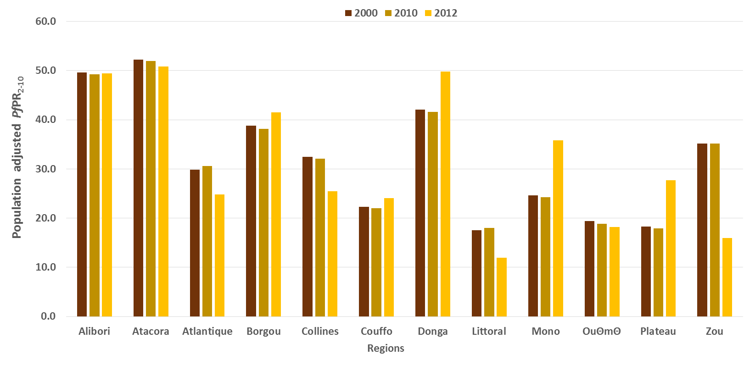

Figure 9 Pie charts showing the changing population at risk of P. falciparum malaria in 2010 and 2012 by PfPR₂₋₁₀ endemicity class in Benin.
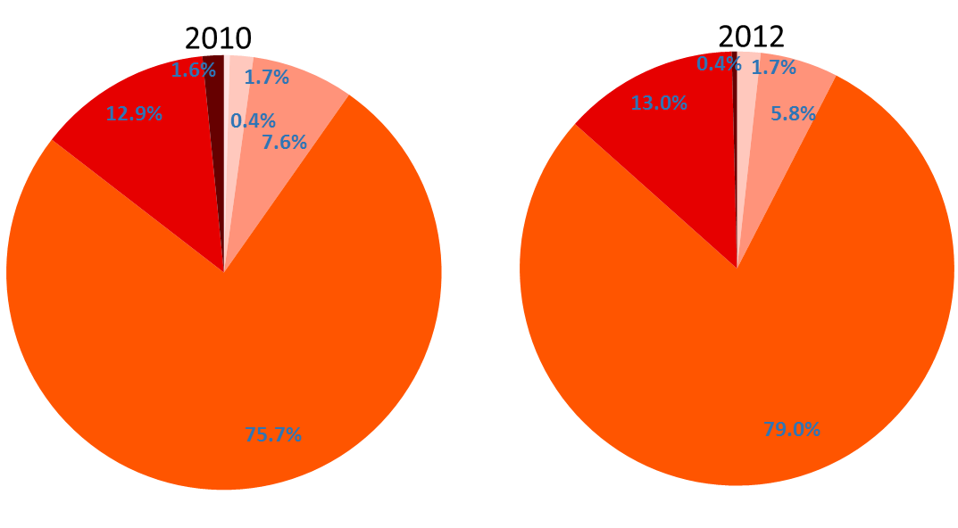
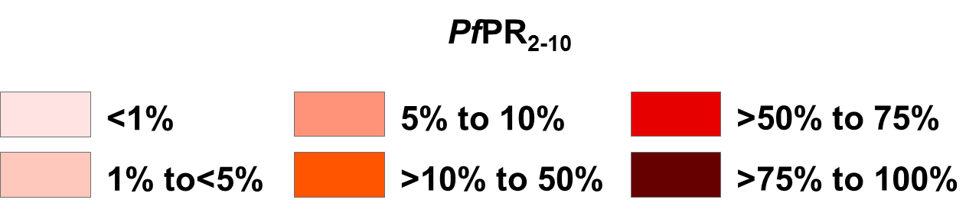

Provisional interpretation of P. falciparum risk in Benin

- It was not possible to make reliable predictions to 2000 due to limited historical data to reliably model P. falciparum transmission intensity for this year. Second, although the MIS of 2012 had 735 clusters, 688 (94%) had sample size of less than 10 people examined. The inclusion of data of such low sample sizes in the model would have compromised the precision of predictions. Instead clusters close in distance (within 5km of each other) were combined into aggregate cluster. Through this process, the MIS 2012 data were reduced to 184 clusters with sample size greater than equal to 10 persons examined. The data together with 90 clusters from the period 1980-2011 were included in the prediction of malaria risk in Benin only for the years 2010 and 2012.

- In 2010, three districts in Benin (Banikoara, Kouande and Tanguieta) had mean PAPfPR₂₋₁₀ of >50%. These districts accounted for 0.68 million (7.7%) of the population in 2010. Only one district (Cotonou 1 Et 4) had PAPfPR₂₋₁₀ of ≤10%. The remaining 30 district had PAPfPR₂₋₁₀ of 12% to 50% in 2000.

- By 2012, three districts ((Cotonou 1 Et 4, Cotonou 2 Et 3 and Cove) had mean PAPfPR₂₋₁₀ of ≤10% while five districts had (Banikoara, Djougou, Malanville, Natitingou, Tanguieta) had mean PAPfPR₂₋₁₀ of >50%. These hyperendemic districts accounted for 1.26 million (13.5%) of the population in 2012. %. The remaining 26 district had PAPfPR₂₋₁₀ of 11% to 48% in 2012.

- In 2010, 1.28 million (14.5%) and 6.5 million (74%) of the population in Benin lived in areas where transmission was >10% - 50% PfPR₂₋₁₀ (mesoendemic) respectively. However, by 2012, 1.25 million (13.4%) and 7.18 million (77%) of the population lived in areas where transmission was >50% PfPR₂₋₁₀ or >10% - 50% PfPR₂₋₁₀ respectively.

- Throughout the period 2010-2012, transmission has remained largely mesoendemic in Benin with the number of districts supporting hyperendemic or holoendemic transmission increasing from 3 to 5. However, majority of regions have shown reductions in mean PAPfPR₂₋₁₀ of except in Couffo, Donga, Mono and Plateau where there appears to have been a rise in infection prevalence.

- Given the moderate to high malaria transmission in Benin the primary mechanism for prevention of malaria should be universal coverage with long lasting insecticidal nets (LLINs) across the country, except perhaps in urban areas.

5.0 References

Cohen JM, Moonen B, Snow RW, Smith DL. How absolute is zero? An evaluation of historical and current definitions of malaria elimination. Malaria Journal 2010; 9: 213.

Griffin JT, Hollingsworth D, Okell LC, Churcher TS, White M, et al. Reducing Plasmodium falciparum malaria transmission in Africa: a model based evaluation of intervention strategies. PLoS Medicine 2010; 7: e1000324.

Guerra CA, Snow RW, Hay SI. Defining the global limits of malaria transmission in 2005. Advances in Parasitology 2006; 62: 157-179.

Guerra CA, Gikandi PW, Tatem AJ, Noor AM, Smith DL,et al. The limits and intensity of Plasmodium falciparum: implications for malaria control and elimination worldwide. PLoS Medicine 2008 ; 5: e38.

Institut National de la Statistique et de l’Analyse Économique (INSAE) et ICF International (2013). Enquête Démographique et de Santé du Bénin 2011-2012. Calverton, Maryland, USA : INSAE et ICF International.

Killeen GF, Smith TA, Ferguson HM, Mshinda H, Abdulla S, Lengeler C, Kachur SP (2007). Preventing Childhood Malaria in Africa by Protecting Adults from Mosquitoes with Insecticide-Treated Nets. PLoS Medicine; 4:e229.

Lumley T .Leaps: regression subset selection (R package) Version 2.7. 2010.

Lysenko AJ, Semashko IN . Geography of malaria. A medico-geographic profile of an ancient disease [in Russian]. In: Lebedew AW, editor. Moscow: Acad Sci USSR; 1968. p. 25-146.

Macdonald G, Göeckel GW. The malaria parasite rate and interruption of transmission. Bull World Health Org 1964; 31: 365–377.

Metselaar D & van Thiel PH. Classification of malaria. Trop Geogr Med 1959; 11: 157–161.

Miller A. Subset Selection in Regression. Boca Raton, FL: Chapman & Hall,2002.

Noor AM, Kinyoki DK, Mundia CW, Kabaria CW, Wambua JM, Alegana VA, Fall IS, Snow RW (2014). The changing risk of Plasmodium falciparum malaria infection in Africa: 2000—10: a spatial and temporal analysis of transmission intensity. Lancet; 383: 1739-1747.

Okell LC, Paintain LS, Webster J, Hanson K, Lines J. From intervention to impact: modelling the potential mortality impact achievable by different long-lasting, insecticide-treated net delivery strategies. Malaria Journal 2012; 11:327.

Pull JH, Grab B. A simple epidemiological model for evaluating the malaria inoculation rate and the risk of infection in infants. Bull World Health Org 1974; 51: 507-516.

R-INLA project. http://www.r-inla.org/ (accessed May 10, 2014).

Rue H, Martino S, Chopin N. Approximate Bayesian inference for latent Gaussian models by using integrated nested Laplace approximations. Journal of Royal Statistical Society Series 2009; 71: 319–392.

Smith DL, Hay SI, Noor AM, Snow RW. Predicting changing malaria risk after expanded insecticide-treated net coverage in Africa. Trends in Parasitology 2009; 25: 511-516.

Smith DL, Guerra CA, Snow RW, Hay SI (2007). Standardizing estimates of malaria prevalence. Malaria Journal; 6: 1

Snow RW, Amratia P, Kabaria CW, Noor AM, Marsh K (2012). The changing limits and incidence of malaria in Africa: 1939-2009. Advances in Parasitology; 78: 169-262

Snow RW, Marsh K. Malaria in Africa: progress and prospects in the decade since the Abuja Declaration. Lancet 2010; 376: 137-139.

The WorldPop Project. www.worldpop.org. (Accessed May 18, 2014).

The GFATM New Funding Model: http://www.theglobalfund.org/en/fundingmodel/

A temperature suitability index was used to provide a means to exclude the possibilities of transmission based on the average vector's life-span, monthly ambient temperature and the duration of sporogony [Gething et al., 2011]. For extreme aridity, the enhanced vegetation index (EVI) from 12 monthly surfaces has been used in previous global malaria risk maps to classify into areas unlikely to support transmission as areas without two or more consecutive months of an EVI >0.1 [Guerra et al., 2006; Guerra et al., 2008]. The history database of the global environment (HYDE) population dataset provides a modelled projection of population distributions and was used to identify those areas in 2000 with population density less than 1 person per 100 km². These biological receptive limits were adjusted according to temporal information on elimination status, medical intelligence and reported case data for the years 2000 and 2010 to define the limits of P. falciparum transmission.
Where age was not specified in the report for each survey but stated that the entire village or primary school children examined we assumed age ranges to be 0-99 years or 5-14 years respectively. Where additional information to provide unique time, village, and complete data was necessary and it was possible to contact authors by email we entered correspondence to provide any missing information.
To select the combination of covariates that best predicted PfPR₂₋₁₀ we conducted a total-sets analysis based on a generalized linear regression model and implemented in bestglm package in R [Miller, 2002; Lumley, 2010]. The best combination of covariates, those with the lowest value of the Bayesian Information Criteria (BIC) statistic [Schwarz, 1978], was selected for the predictive models of malaria risk and included TSI and EVI.
In the SPDE approach, the overall hierarchical space-time binomial model of the prevalence to malaria parasite was represented as the realization of a spatial-temporal process of the PfPR₂₋₁₀ at the community location and time, the covariates (TSI and EVI) vector for the given location and time, the coefficient vector and the measurement error defined by the Gaussian white noise process. The realization of state process or the unobserved level of PfPR₂₋₁₀ is defined by a spatial-temporal Gaussian field that changes temporally as a second-order autoregressive function. The hold-out set was selected using a spatially and temporally declustered algorithm [Isaacs & Svritsava 1989] which defined Thiessen polygons around each survey location. Each data point had a probability of selection proportional to the area of its Thiessen polygon so that data located in densely surveyed regions had a lower probability of selection than those in sparsely surveyed regions setting a high threshold for model performance. The Bayesian spatio-temporal geostatistical model was then implemented in full using the remaining 90% of data and predictions were made to the 10% hold-out.

